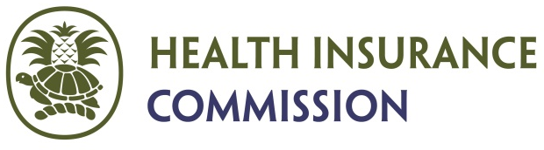

Guidance Notes
APPLICATION FOR THE STANDARD HEALTH INSURANCE CONTRACT
PREMIUM PAYMENT ASSISTANCE PROGRAM (PPAP) FOR DISPLACED TOURISM SECTOR WORKERS

These guidance notes are intended to provide useful information if you are applying for assistance with the payment of the premium for the Standard Health Insurance Contract (SHIC) for displaced tourism sector workers.

- Deadline to submit application for February 2022 assistance is WEDNESDAY, JANUARY 19, 2022.
- Eligible applicants include persons who are legal residents and currently residing in the Cayman Islands and are currently unemployed or not working full-time in the Tourism/Hospitality Sector as a result of the COVID -19 Pandemic.
- Assistance will not be provided to any applicant on a work permit.
- The employer must be a legal company currently licensed with the appropriate Department/Agency/Authority/Board in the tourism sector.
- Self-employed applicant would also need to provide evidence regarding their legitimate tourism/hospitality sector business.
- An individual applicant who was an employee in the tourism sector must provide information regarding their (previous) employer and their health insurance coverage including the name of their employer, the name of the approved insurer, health insurance policy number.
- Eligible applicants including any dependent(s) must provide information that they had at a minimum, health insurance coverage under the SHIC.
- Applications must be submitted on a month-by-month basis.
- Assistance will not be provided to reinstate or reactivate terminated health insurance policies.
- Assistance will not be provided to any applicant receiving coverage through the Needs Assessment Unit (NAU), under their spouse, or any other program that provides health insurance benefits.
- Assistance with partial payment of the premium will be given favorable consideration.
- Once an application has been duly considered the applicant will be provided with information on the way forward with the request for assistance.
- The premium for approved applicants will be paid directly to the approved insurer.
- The Health Insurance Commission is requesting to be informed immediately once an applicant is able to resume the payment of their health insurance premium.

REQUIRED SUPPORTING DOCUMENTATION
- Completed application form with any supporting documentation to validate the need for the assistance.
- Any other information that the applicant would consider to be helpful to support the application
Definitions:
“employee” means any individual who enters into or works under a contract of employment with an employer whether the contract be oral or written, express or implied, and the term includes a person whose services have been interrupted by a suspension of work during a period of leave or temporary lay-off;

“employer” means any person who has entered into a contract of employment with an employee, and includes any agent, representative or manager of such person who is placed in authority over an employee;

“dependant”, in relation to an insured person or a prospective insured person, means a child of that person, the unemployed spouse of that person, and any dependent offspring of that person;

“self-employed person” means a person over school leaving age whose earnings (otherwise than in the capacity of an employee) derive from his production (in all or part) of goods or services in or from the Islands;

Applications and Supporting Documentation must be submitted via email to hic@gov.ky or placed in the Drop Box, 1st Floor Government Administration Building, 133 Elgin Avenue, George Town, Grand Cayman.
For inquiries please contact the Health Insurance Commission on 946-2084.

